Operating Systems Project – PHASE 2 Report

INTRODUCTION
The Domain Name System (DNS) is a fundamental network service that translates human-readable domain names into IP addresses. DNS simplifies network communication by allowing users and systems to access resources using domain names instead of numeric IP addresses. In this task, a DNS server is configured on Ubuntu using BIND9 to provide name resolution services within the network.

IMPLEMENTATION
Role Assignment
- Ubuntu 1 → DNS Server
- Ubuntu 2 → DNS Client
- Domain → oslab.lab
- DNS Server IP → 192.168.153.129
Step 1 – Install DNS Server (BIND9) - Ubuntu 1
BIND9 is the most commonly used DNS server software on Linux systems. It translates domain names into IP addresses.
sudo apt update
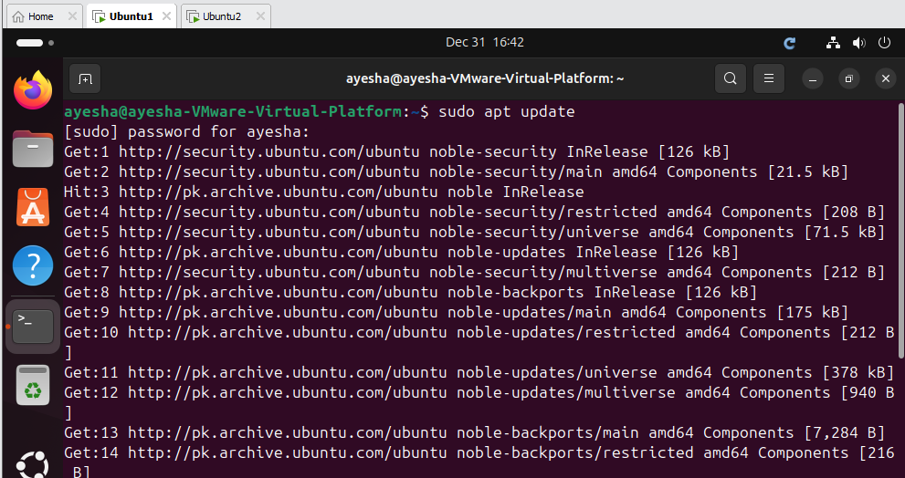
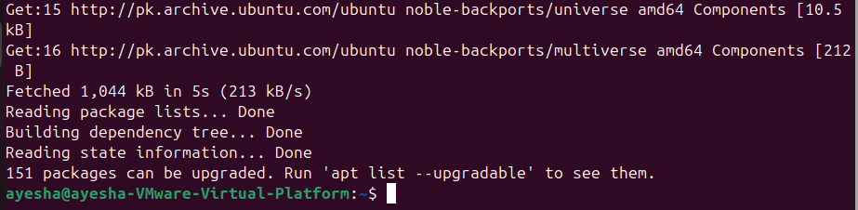
sudo apt install bind9 bind9utils bind9-doc -y
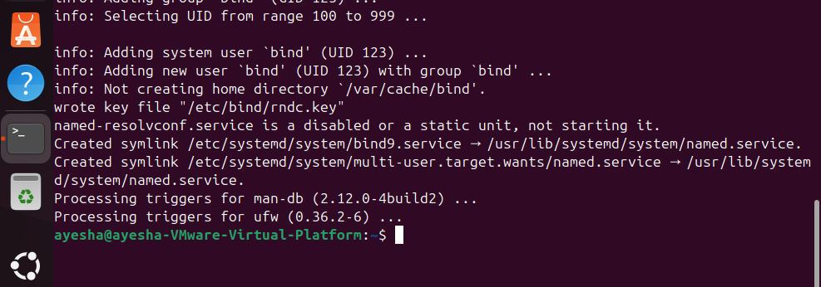
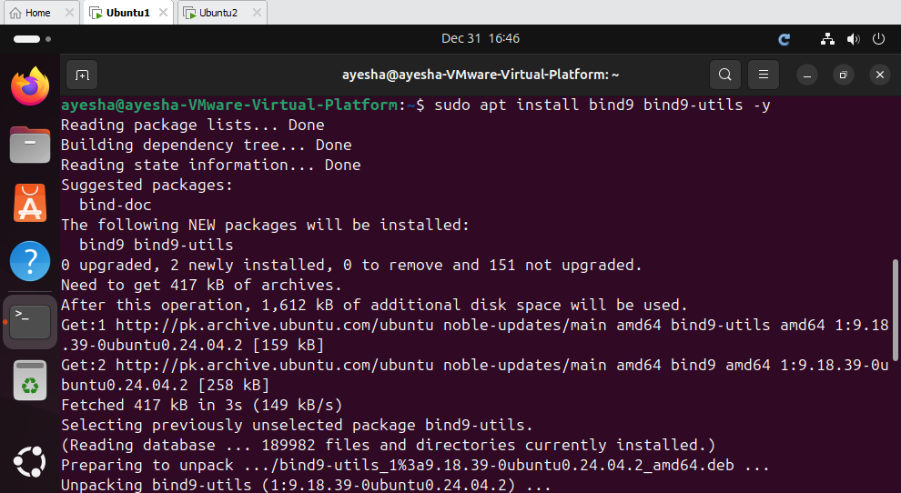

Step 2 – Check DNS Service Status (Verify BIND is Running)
sudo systemctl status bind9
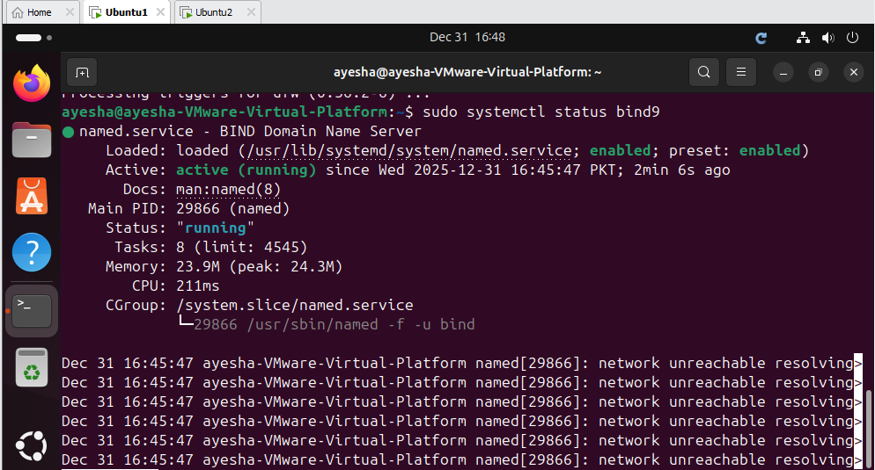
Service showing active (running)

Step 3 – Configure DNS Options (Ubuntu-1)
sudo nano /etc/bind/named.conf.options
Replace everything inside with:
options {
directory "/var/cache/bind";

listen-on { any; };
listen-on-v6 { any; };
allow-query { any; };
recursion yes;
dnssec-validation auto;
};
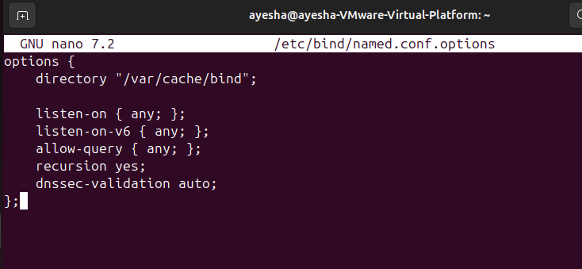

Step 4 – Define DNS Zone (Ubuntu-1)
sudo nano /etc/bind/named.conf.local
Add:
zone "oslab.lab" {
type master;
file "/etc/bind/db.oslab.lab";
};
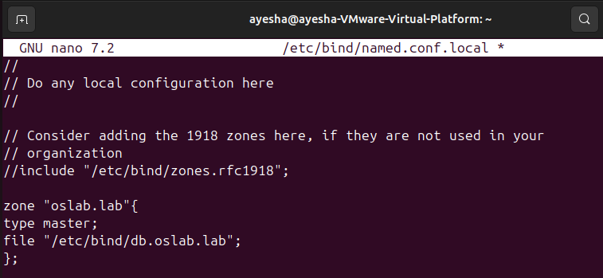

Step 5 – Create Zone File (Ubunt-1)
sudo cp /etc/bind/db.local /etc/bind/db.oslab.lab
sudo nano /etc/bind/db.oslab.lab
Replace content with:
$TTL 604800
@ IN SOA oslab.lab. root.oslab.lab. (
2 ; Serial
604800 ; Refresh
86400 ; Retry
2419200 ; Expire
604800 ) ; Negative Cache TTL
;
@ IN NS oslab.lab.
@ IN A 192.168.25.131
www IN A 192.168.25.131
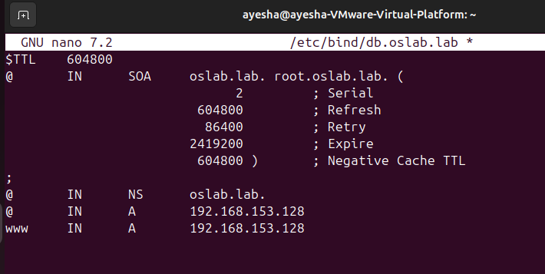

Step 6 – Check DNS Configuration (Ubuntu-1)
sudo named-checkconf
sudo named-checkzone oslab.lab /etc/bind/db.oslab.lab
Expected:
OK
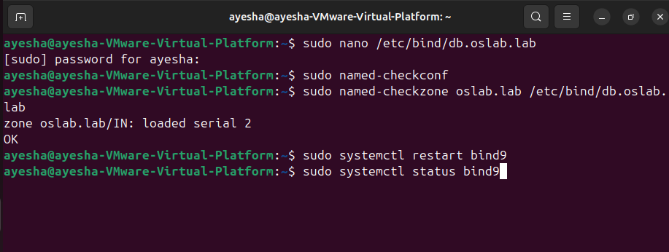

Step 7 – Restart DNS Server
sudo systemctl restart bind9
Verify:
sudo systemctl status bind9
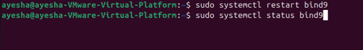
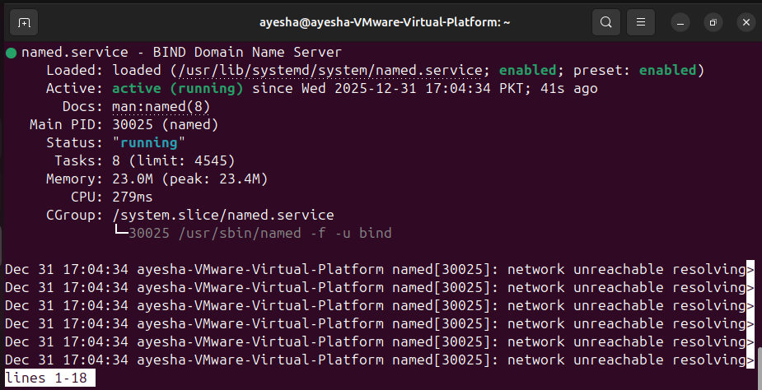

Step 8 – Test DNS Locally (Ubunt-1)
dig oslab.lab @127.0.0.1
Expected:
ANSWER SECTION:
oslab.lab. IN A 192.168.153.128

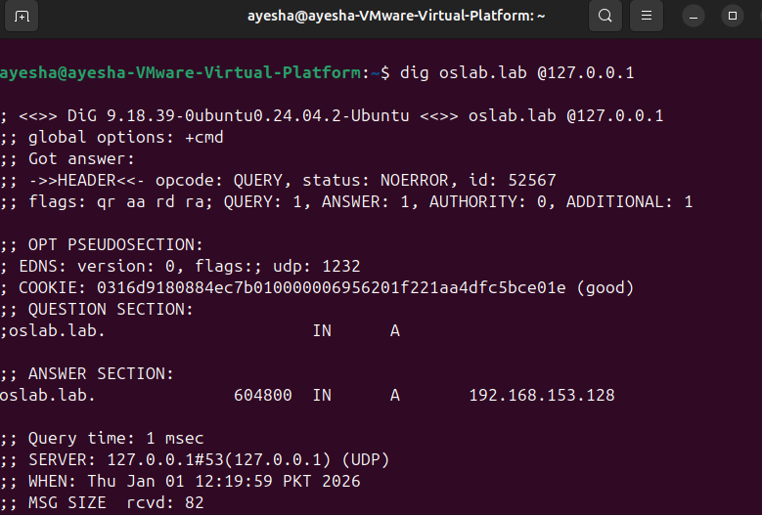
Step 9 – Configure DNS Client (Ubuntu-2)
Set DNS server:
sudo resolvectl dns ens33 192.168.153.128
sudo resolvectl domain ens33 oslab.lab
resolvectl status

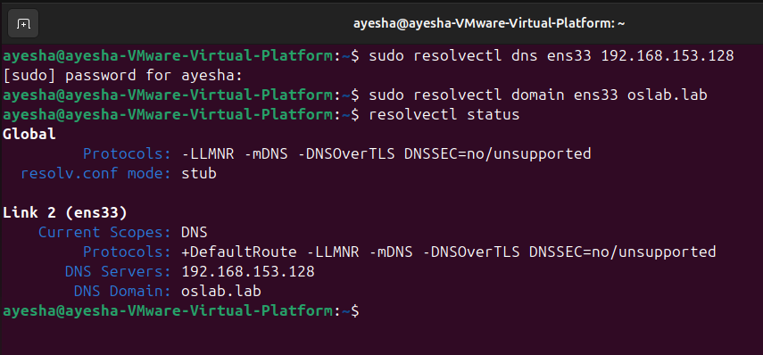
Step 10 – FINAL TEST (Ubuntu-2)
ping oslab.lab
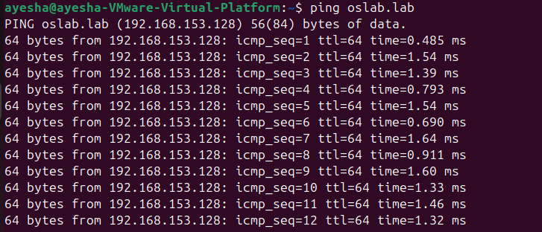
ping www.oslab.lab
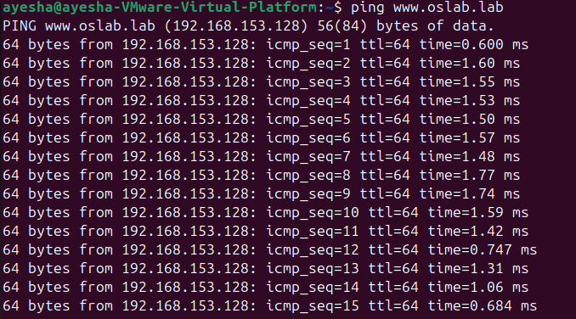

CONCLUSION
The DNS server was successfully configured on Ubuntu using BIND9. The server correctly resolved domain names to IP addresses for client systems, demonstrating proper DNS functionality. This implementation confirms effective name resolution within the network environment.

